Phase Four-Fix XSS Security Vulnerabilities in Application

Yingwei Liu

Liberty University

Abstract

This article focuses on demonstrate the correction of XSS security vulnerabilities that we discovered in the phase two - Initial Static Security Scan of Hackazon Code using RIPS.

First, it will present the snippets of before and after vulnerable code section in the top of the repost. Then updated Rips scan and discuss the XSS class of vulnerability and provide a recommendation of how to fix that vulnerability.

Keywords: Hackazon, Vulnerabilities, RIPS, XSS

Phase Four-Fix XSS Security Vulnerabilities in Application

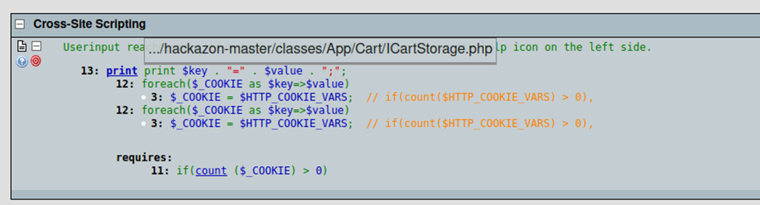

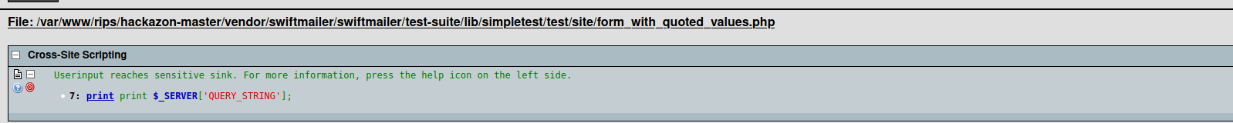

These three vulnerabilities were discovered and reported in the Phase two lab report. Now I will need to fix these three vulnerabilities for the Hackazon web application.

# Fix the Vulnerabilities for the Hackazon

The first vulnerabilities for the Hackazon was a cross-site scripting, the user input can reaches sensitive information.

Original code for the cross-site scripting

Updated code

## Second Vulnerabilities

Original Code

Updated Code

### Third Vulnerabilities

Original Code.

**Updated Code.**

In addition, I apply the htmlentities function to convert the character input to html entities. According to the Acunetix, “To keep yourself safe from XSS, you must sanitize your input. Your application code should never output data received as input directly to the browser without checking it for malicious code.” Just like the John 10:28-29, “and I give eternal life to them, and they will never perish; and no one will snatch them out of My hand. My Father, who has given them to Me, is greater than all; and no one is able to snatch them out of the Father’s hand.”

References

Acunetix. Cross-site Scripting. Retrived from https://www.acunetix.com/websitesecurity/cross-site-scripting/

Bible, Retrieved from https://bible.knowing-jesus.com/topics/Security.